- What are three reasons for the downward slope of the demand curve?
Reason 1:

Reason 2:

Reason 3:
- True or False. An increase in the price shifts the whole demand curve to the left.
- List 3 shifters/determinants of supply.


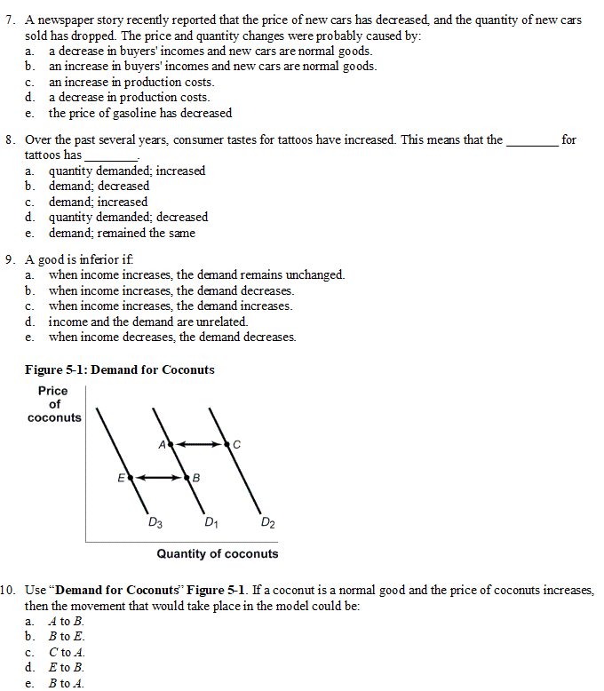
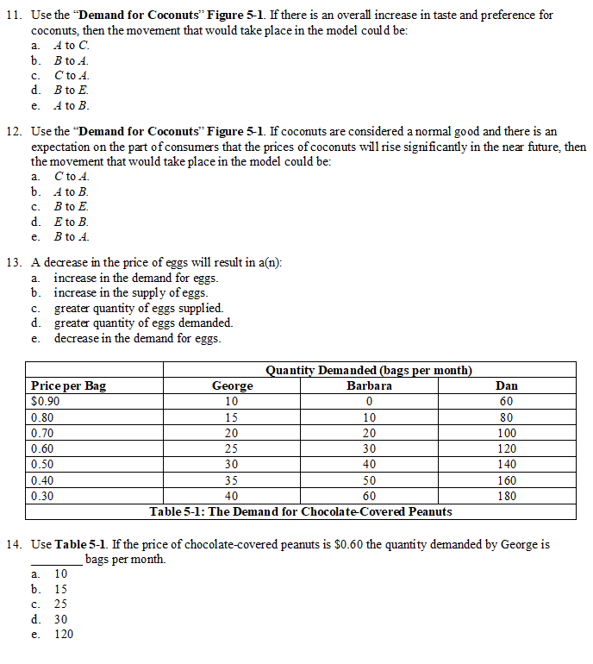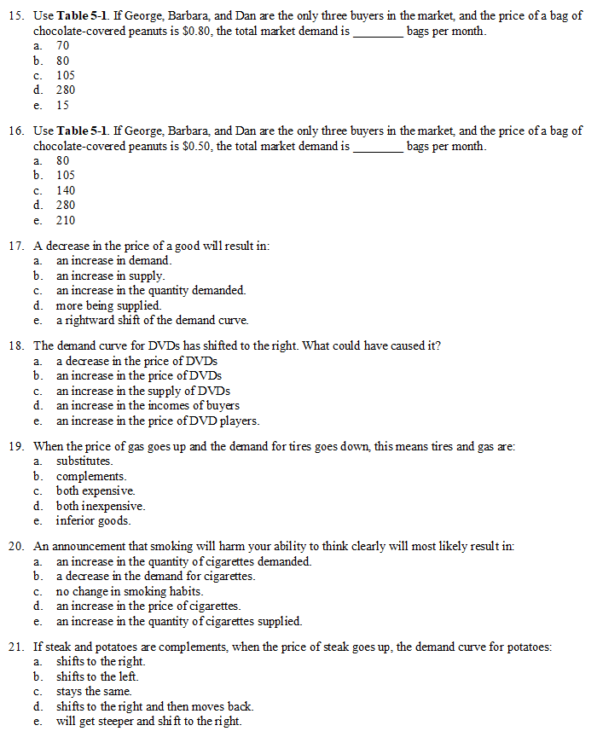

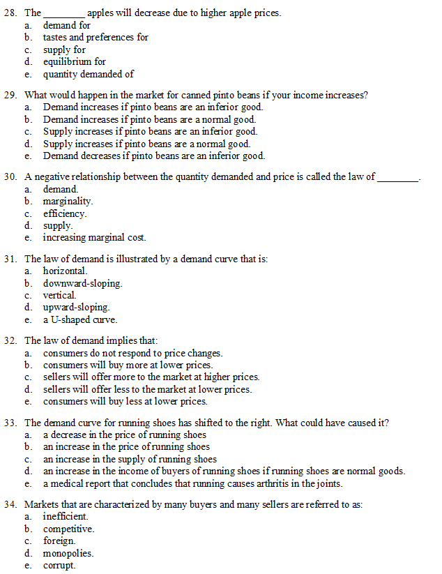


Answers
- Diminshing marginal utility
Income effect – as price decreases you have more money to spend on all goods
Subsitution effect – as price decreases, you buy more of the cheaper good and less of other goods

2 False

3 Price of materials
Subsidies/taxes
Technology

1 | E | 6 | B | 11 | A | 16 | E | 21 | B | 26 | C | 31 | B | 36 | A
2 | B | 7 | A | 12 | D | 17 | C | 22 | A | 27 | D | 32 | B | 37 | E
3 | B | 8 | C | 13 | D | 18 | D | 23 | D | 28 | E | 33 | D | 38 | B
4 | C | 9 | B | 14 | C | 19 | B | 24 | B | 29 | B | 34 | B | 39 | E
5 | E | 10 | E | 15 | C | 20 | B | 25 | E | 30 | A | 35 | B | 40 | A

